Limbal Relaxing Incision Post-Operative Drop Instructions
Surgery performed on:
RIGHT EYE LEFT EYE
Please bring all post-operative drops to your 1-day appointment for review.

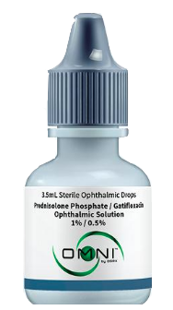
2 in 1 Combination Drops – to be provided by your Patient Counselor
Drop name – Prednisolone/Gatifloxacin Ophthalmic Solution
Cap color – Grey
Instructions: Start date: ______________ End date: ______________
Day #1: apply 1 drop 3 times per day in the eye that had surgery.
Day #2: apply 1 drop 3 times per day in the eye that had surgery.
Day #3: apply 1 drop 3 times per day in the eye that had surgery. Then discontinue.

--OR--

Individual Drops – to be filled and provided by your Pharmacy
**You must pick up 2 drops from your pharmacy prior to LRI surgery**
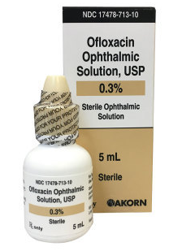
**Apply drops a minimum of 3 minutes apart**

- Drop name – Ofloxacin or Besivance
Cap color – Tan
Instructions: Start date: ______________ End date: ______________
Day #1-3 – use 1 drop 3 times per day for 1 week in the surgical eye.
Then discontinue.

- Drop Name – Lotemax Gel or Prednisolone Acetate
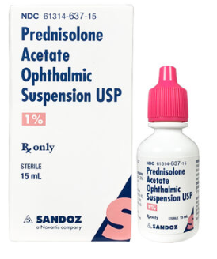
Cap color – Pink or white
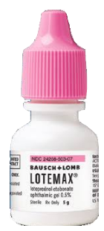
Instructions: Start date: ______________ End date: ______________
Day #1-3 – use 1 drop 3 times per day in the eye that had surgery. SHAKE BOTTLE.
Then discontinue.

