LASIK Post-Operative Drop Instructions
Surgery performed on:
RIGHT EYE LEFT EYE
Please bring all post-operative drops to your 1 day and 1 week appointment for review.

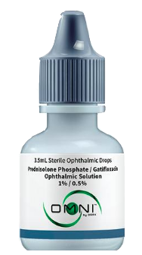
2 in 1 Combination Drops – to be provided by your Patient Counselor
Drop name – Prednisolone/Gatifloxacin Ophthalmic Solution
Cap color – Grey
Instructions: Start date: ______________ End date: ______________
Week #1: apply 1 drop 3 times per day in the eye that had surgery. Then discontinue.
Week #1-4: may use preservative free artificial tears as needed.

--OR--

Individual Drops – to be filled and provided by your Pharmacy
**You must pick up all 2 drops from your pharmacy prior to LASIK surgery**
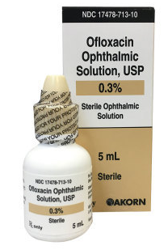
**Apply drops a minimum of 3 minutes apart**

- Drop name – Ofloxacin or Besivance
Cap color – Tan
Instructions: Start date: ______________ End date: ______________
Week #1 – use 1 drop 3 times per day for 1 week in the surgical eye.
Then discontinue.

- Drop Name – Lotemax Gel or Prednisolone Acetate
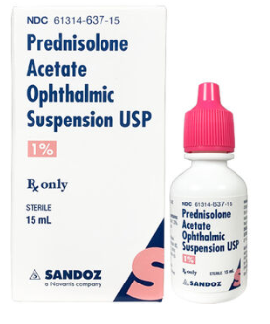
Cap color – Pink or white
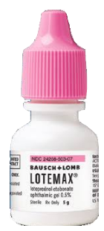
Instructions: Start date: ______________ End date: ______________
Week #1 – use 1 drop 3 times per day in the eye that had surgery. SHAKE BOTTLE.
Then discontinue.

- Preservative Free Artificial Tears
Recommended Brands – Refresh, Systane, Thera Tear
Instructions:
Week #1-4 – may use preservative free artificial tears as needed

