ICL Post-Operative Drop Instructions
Surgery performed on:
RIGHT EYE LEFT EYE
Please bring all post-operative drops to your 1 day and 1 week appointment for review.

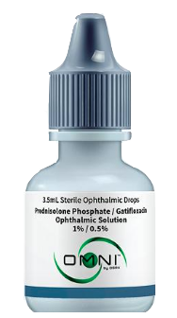
2 in 1 Combination Drops – to be provided by your Patient Counselor
- Drop name – Prednisolone/Gatifloxacin Ophthalmic Solution
Cap color – Grey
Instructions: Start date: ______________ End date: ______________
Week #1 – apply 1 drop 3 times per day in the eye(s) that had surgery.
Then discontinue.

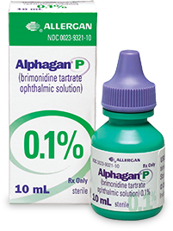
- Drop Name – Alphagan P or Brimonidine
Cap color – Green
Instructions: Start date: ______________ End date: ______________
Week #1– apply 1 drop 3 times per day in the eye(s) that had surgery.
Then discontinue.

--OR--

Individual Drops – to be filled and provided by your Pharmacy
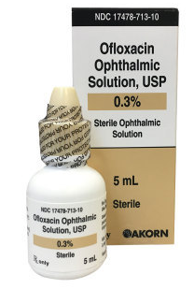
**You must pick up all 3 drops from your pharmacy prior to ICL surgery**
**Apply drops a minimum of 3 minutes apart**

- Drop name – Ofloxacin or Besivance
Cap color – Tan
Instructions: Start date: ______________ End date: ______________
Week #1 – use 1 drop 3 times per day for 1 week in the surgical eye(s).
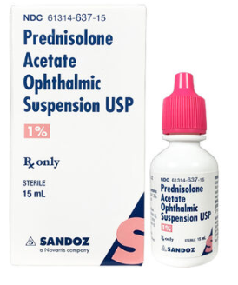
Then discontinue.

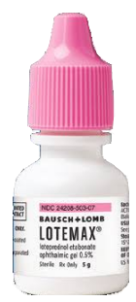
- Drop Name – Lotemax Gel or Prednisolone Acetate
Cap color – Pink or white
Instructions: Start date: ______________ End date: ______________
Week #1 – apply 1 drop 3 times per day in the eye(s) that had surgery.
SHAKE BOTTLE. Then discontinue.
- Drop Name – Alphagan P or Brimonidine
Cap color – Green
Instructions: Start date: ______________ End date: ______________
Week #1– apply 1 drop 3 times per day in the eye(s) that had surgery.
Then discontinue.

