IOL Post-Operative Drop Instructions
Surgery performed on:
RIGHT EYE LEFT EYE
Please bring all post-operative drops to your 1 day and 1 week appointment for review.

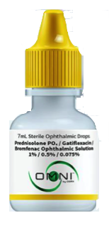
3 in 1 Combination Drops – to be provided by your Patient Counselor
Drop name – Prednisolone/Gatifloxacin/Bromfenac Ophthalmic Solution
Cap color – Yellow
Instructions: Start date: ______________ End date: ______________
Week #1: apply 1 drop 3 times per day in the eye that had surgery.
Week #2: apply 1 drop 2 times per day in the eye that had surgery.
Week #3: apply 1 drop 2 times per day in the eye that had surgery. Then discontinue.
Week #4: after 21 days drop should be discontinued. See instruction above.

--OR--

Individual Drops – to be filled and provided by your Pharmacy
**You must pick up all 3 drops from your pharmacy prior to cataract surgery**
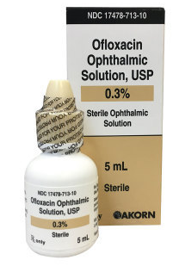
**Apply drops a minimum of 3 minutes apart**

- Drop name – Ofloxacin or Besivance
Cap color – Tan
Instructions: Start date: ______________ End date: ______________
Week #1 – use 1 drop 3 times per day for 1 week in the surgical eye.
Then discontinue.

- Drop Name – Lotemax Gel or Prednisolone Acetate or Durezol
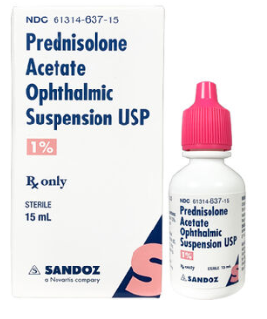
Cap color – Pink or white
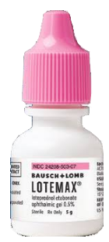
Instructions: Start date: ______________ End date: ______________
Week #1 – use 1 drop 3 times per day in the eye that had surgery. SHAKE BOTTLE.
Week #2 – use 1 drop 2 times per day in the eye that had surgery. SHAKE BOTTLE.
Week #3 – use 1 drop 2 times per day in the eye that had surgery. SHAKE BOTTLE.
Then discontinue.

- Drop Name – Diclofenac or Ketorolac or Prolensa
Cap color – Grey
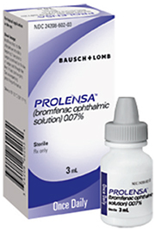
Instructions: Start date: ______________ End date: ______________
Week #1 – use 1 drop 3 times per day in the eye that had surgery.
Week #2 – use 1 drop 3 times per day in the eye that had surgery.
Week #3 – use 1 drop 3 times per day in the eye that had surgery.
Then discontinue.
**If you have Prolensa, use drop 1 time per day in the eye that had surgery for 4 weeks.

